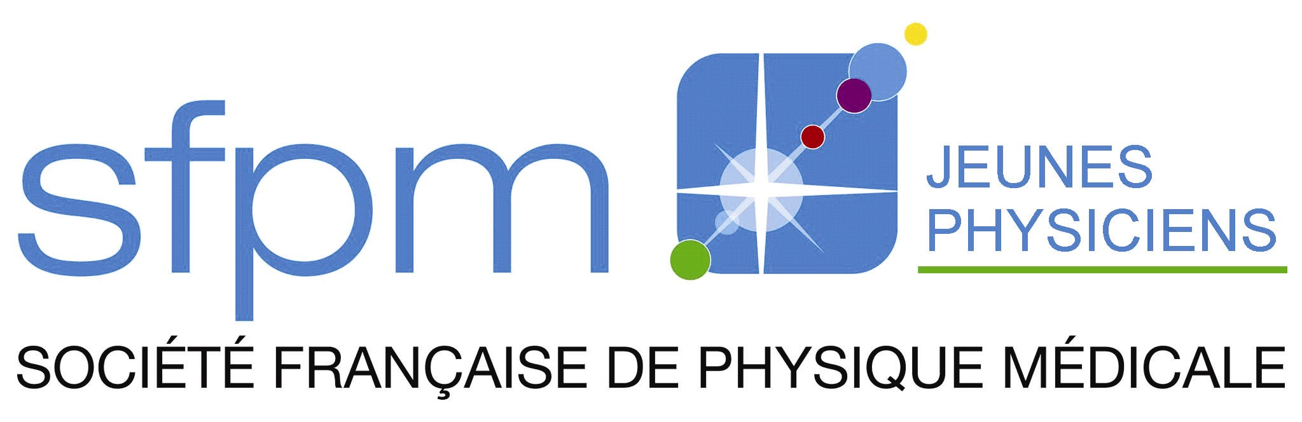

This is the title of the english template with a single capital letter
Merci de rajouter ici le titre de votre résumé en français
FirstnameA. Authorª, FirstnameB. Co-authorª, FirstnameJ.R. Redactor^{b}

ªDepartment_1/City/Country
^{b}Department_2/ City/Country

Introduction: This is the introduction section. Note that Authors have a single capital letter. An affiliation is mentioned for each of them. Please start from this template rather than an empty Word file. The structure of the abstract (introduction/methods/results/conclusions) is MANDATORY.

Material and Methods: Material and methods are described here. No specific type is recommended for references. Condensed references can be directly inserted in the text (Churchill, 2010) to save characters. Alternatively, references can be detailed at the end of the abstract with for instance a Nature template which is rather efficient¹.

Results: Results are described here. Abstract must not exceed 3000 characters (space included) starting from the word “Introduction” until the last character of the reference section. These characters will be paste in the “Résumé” field at the first step of the submission process.

Conclusions: This is the conclusions section. This year, no abstract will be published in Physica Medica. An abstract in French is recommended but you can submit an abstract in English if you prefer. After the congress, some abstracts will be selected for a manuscript submission in Physica Medica.

References
1. Rosenzweig, K. E. et al. The deep inspiration breath-hold technique in the treatment of inoperable non-small-cell lung cancer. Int. J. Radiat. Oncol. Biol. Phys. 48, 81–87 (2000).

